**YEAR 11 PHYSICS**

**MOVEMENT TEST I**

**2023**

**Student name**: ________________________________________ Marks: / **33**

|  |  |
| --- | --- |
|  | [Image result for physics cartoons](https://www.google.com/url?sa=i&rct=j&q=&esrc=s&source=images&cd=&ved=2ahUKEwjX39_39-HjAhWQe30KHXqODXQQjRx6BAgBEAU&url=https%3A%2F%2Fwww.facebook.com%2Fphysicsfootnotes%2Fphotos%2Fcartoons-can-provide-an-excellent-stimulus-for-physics-discussions-forcing-us-to%2F1918504558390316%2F&psig=AOvVaw1MhgsYLGaO0_vXHF3qaBxV&ust=1564757710000104) |

# **TIME**: 1 Hour

Data sheet supplied

**NOTE:**

1. Calculations must show clear working with answers stated to **three significant figures.**

2. Marks will be allocated for detailed and logical setting out.

3. Place your answer in the designated space under each question.

4.State **assumptions** while attempting open ended type questions.

5. Write in blue/black ink. It is advisable to use a pencil for graphing and diagrams.

**Question 1 (4 marks)**

A very lost goose flies 30.0 km north, then 50.0 km east, then 70.0 km south. Where is the goose now relative to its starting position?

**Question 2 (8 marks)**

On Cecil Andrew’s oval, a student shoots an arrow horizontally at 59.0 m s-1.

1. Draw in and label any acceleration vectors that act on the arrow below.

Note that the arrow is free from the bow and that the arrow is travelling at constant velocity.

Neglect air resistance. *[2 marks]*

1. If the arrow flies horizontally at 59.0 m s-1 and hits a target that brings the arrowhead to

rest in 1.20 ms, determine the average theoretical deceleration of the arrowhead as

it penetrates the target. *[3 marks]*

|  |
| --- |
| Answer |

1. Given that the average deceleration of the arrow is actually - 5.31 x 104 ms-2, determine the theoretical displacement of the arrowhead at t = 0.00126 seconds after the arrowhead hits the surface of the target.  *[3 marks]*

|  |
| --- |
| Answer |

**Question 3 (3 marks)**

A remote control car moves along a straight line. Its displacement from the starting point is shown as a function of time in the graph below.

(a) Determine the displacement of the remote control car at 5.00 s? *[1 mark]*

Answer

(b) Which section, or sections, of the graph represents a constant velocity of   
3.00 m s-1? You must include calculations to justify your answer. *[2 marks]*

Answer

**Question 4 (4 marks)**

A graph of velocity versus time of a ship coming into a harbour is shown below.

1. Describe the motion of the ship based on the graph.  *[2 marks]*

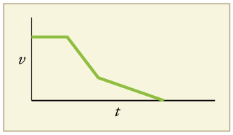

D

C

A

B

**______________________________________________________________________________________________________________________________________________________________________________________________________________________________________________________________________________________________________________________________________________________________________________________________________________________________________________________**

(b) What would a graph of the ship’s acceleration versus time look like? Draw a sketch in the space provided below. *[2 marks]*

**Question 5 (3 marks)**

Dr Pitts is driving her car down Ranford road and sees the traffic lights turn amber when she is 22.0 m from them. She has a fast reaction time of 0.400 s and is travelling at 17.5 m s-1. Determine through calculation whether she will be able to stop at the traffic lights if the car decelerates at 8.20 m s-2? **Tick the box to indicate your answer.**

|  |  |
| --- | --- |
| **YES,** she will stop in time |  |
| **NO,** she won’t stop in time |  |

**Question 6 (6 marks)**

Geraldine threw a 2.20kg pumpkin vertically upwards at an initial speed of 3.20ms-1. She caught the pumpkin as it fell back down. Ignore air resistance in this problem.

1. Calculate the maximum height, above Geraldine’s hand, to which the pumpkin rose. *[3 marks]*

Answer

1. The pumpkin’s final velocity was its velocity at the instant that it reached Geraldine’s hand again on its downward flight. Determine the magnitude of the pumpkin’s final velocity and justify your answer.

*[3 marks]*

|  |
| --- |
| Answer |

**Question 7 (5 marks)**

The diagram below shows the merging lane of the on-ramp of a busy freeway. A set of traffic lights is installed at X, 4.00 x 102 m from Y where the cars merge into the traffic flow. The vehicles on the busy freeway are travelling at a constant speed of 90.0 km h–1. When car A, is a distance ***d*** along the road from point Y, is at the position shown, the traffic light at X changes to green. Car B, at the traffic light, is then expected to uniformly accelerate to 90.0 km h–1 at Y and merge into traffic beside car A. Calculate the distance ***d***. (You mustshow your working.)

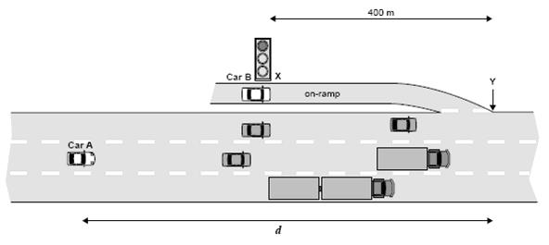

Answer